**LAB#13**

* Using any three sensor design a digital screen, write detail about that sensor and also describe how it is related to Human Computer Interaction.

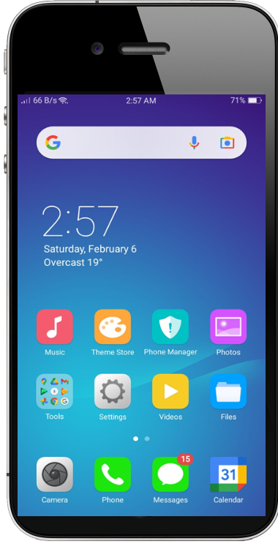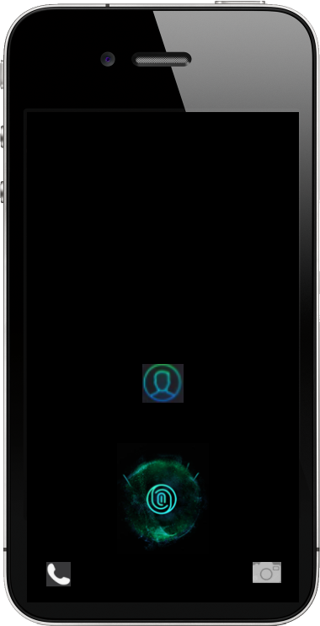 **1 2**

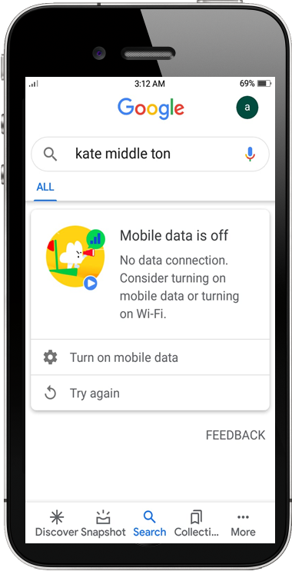 **3 4**

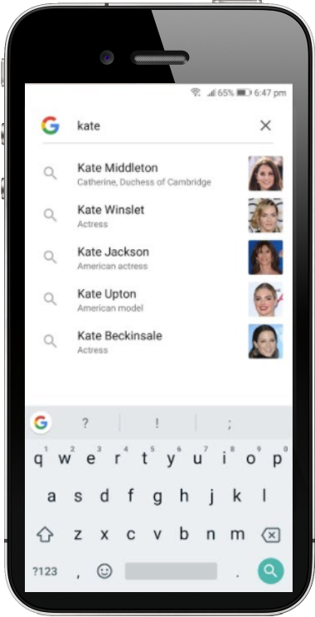

**5**

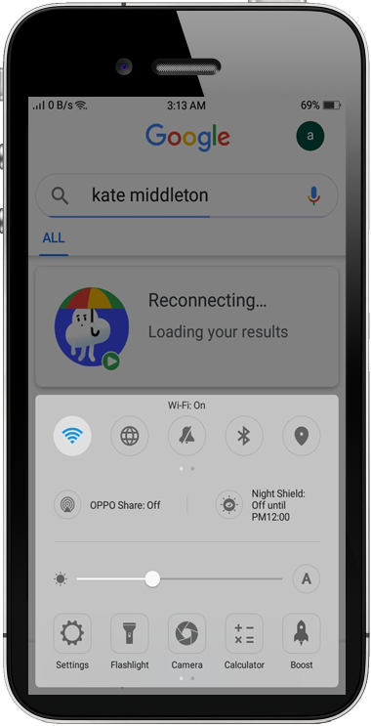

**Sensor We Used**

1. **Finger Print Identity Sensor**

The sensor uses advanced touch screen or power button the sensor focus on your fingerprint to capture high resolution images of your fingerprint. Touch ID reads fingerprints in 360-degrees of orientation, analyses the sub epidermal layers of the skin and categorizes each fingerprint into arch, loop or whorl categories. Touch ID then maps individual details of fingerprint ridges, including variations like pores, and compiles all of the data together. Touch ID then uses this data to match and recognize fingerprints

1. **Touch Screen**

It can be of three types capacitive, surface acoustic wave and resistive

All have different procedure of detecting finger positions like;

1. Two layer connect on pressing and voltage generate between them in resistive which use to where the finger is pointing
2. Surface acoustic wave uses [ultrasonic](https://en.wikipedia.org/wiki/Ultrasound) waves that pass over the touchscreen panel. When the screen is touched, a portion of the wave is absorbed. The change in ultrasonic waves is processed by the [controller](https://en.wikipedia.org/wiki/Controller_(computing)) to determine the position of the touch event
3. A capacitive touchscreen panel consists of an [insulator](https://en.wikipedia.org/wiki/Insulator_(electrical)), such as [glass](https://en.wikipedia.org/wiki/Glass), coated with a transparent [conductor](https://en.wikipedia.org/wiki/Electrical_conductor), touching the surface of the screen results in a distortion of the screen's [electrostatic](https://en.wikipedia.org/wiki/Electrostatic) field, measurable as a change in [capacitance](https://en.wikipedia.org/wiki/Capacitance). The location is then sent to the controller for processing to find out where he pressed
4. **Wi-Fi**

Wi-Fi gives wireless internet connectivity between multiple devices within a localized area

Wi-Fi works off of the same principal as other wireless devices, it uses radio frequencies to send signals between devices. And to receive the information found in these waves, your radio receiver needs to be set to receive waves of a certain frequency. For Wi-Fi this frequency happens to be

2.4Ghz and 5Ghz.

1. In above interfaces we are trying to show how human interact with his mobile interfaces to achieve daily task and for privacy and security he uses several methods like, thumb or finger impression, retina recognition, PIN or password and voice recognition here we showed finger print impression use as security for mobile data and privacy from kids and other person, here finger print sensor senses and detect your thumb or finger impression and matches with your impression which is already feed in your mobile
2. As human you want to achieve some basic task using your daily routine task like setting alarm, searching, capture selfies here in above given scenario or screen shots we showed he trying to search something so he is searching using keypad which is showing on screen for searching he uses his fingers to type so touch sensor senses which alphabet letter he touches so inner processing show on screen in really very small minor seconds
3. Then he touched search button on screen to search but suddenly internet disconnected so system showed that connectivity lost and then when he reconnect Wi-Fi connection the system showed connecting means google search find out that you don’t have connection to continue your search
4. Above Scenario or screen shots showed us how human interacting with mobile using different sensors to achieve his/her daily routine task or work